PART A
(PART A : TO BE REFERED BY STUDENTS)

Experiment No.01

A.1 Aim:
Implementation of application of stack.
A.2 Prerequisite:
C programming
A.3 Outcome:
After successful completion of this experiment students will be,
Implement various operations using linear data structures.
A.4 Theory:
Stack:
Stack is an ordered, linear list in which, insertion and deletion can be performed only at one end that is called top. Stack is a recursive data structure having pointer to its top element. Stacks are sometimes called as Last-In-First-Out (LIFO) lists i.e. the element which is inserted first in the stack, will be deleted last from the stack.

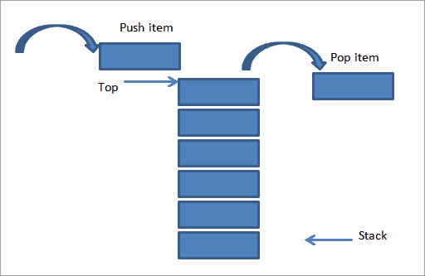

Basic Stack Operations:
- Push: To insert data on the top of the stack
- Pop: To remove data from the top of the stack
- Stack Top: To get the topmost data from the stack
- Stack Empty: To check whether stack is empty
- Stack full: To check whether stack is full

Example:

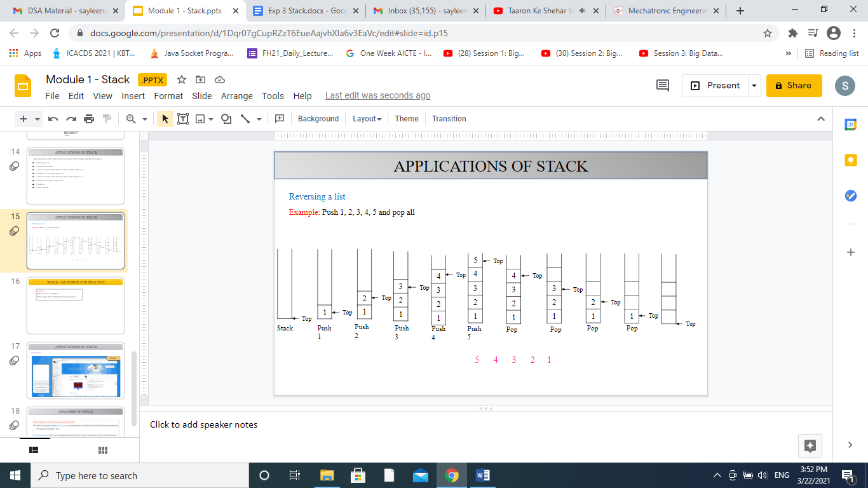

Algorithm:
Implementation of stack using Array:

Declare array stack with size MAX
- Push:
Step 1: Read data
Step 2: if top = n-1 then
Print stack is full and go to step 3
else
top++
Set stack[top] = data
Step 3: Exit

- Pop:
Step 1: if top = -1 then
Print stack is empty and go to step 2
else
Set data = stack[top]
top--
return top
Step 2: Exit

- Stack Top:
Step 1: if top = -1 then
Print stack is empty and go to step 2
else
Set data = stack[top]
Print data
Step 2: Exit

- Stack Empty:
Step 1: if top = -1 then
Print stack is empty and go to step 2
else
Print stack is not empty and go to step 2
Step 2: Exit

- Stack Full:
Step 1: if top = n-1 then
Print stack is full and go to step 2
else
Print stack is not full and go to step 2
Step 2: Exit

PART B
(PART B : TO BE COMPLETED BY STUDENTS)

(Students must submit the soft copy as per following segments within two hours of the practical. The soft copy must be uploaded on the Blackboard or emailed to the concerned lab in charge faculties at the end of the practical in case the there is no Black board access available)

Roll. No.71 | Name: Omkar Gujja
Class: 2 | Batch: MTRX
Date of Experiment: 13/2/2021 | Date of Submission: 20/2/2021
Grade:

B.1 Software Code written by student:
#include<stdio.h>
#include<stdlib.h>

#define Size 4

int Top=-1, inp_array[Size];
void Push();
void Pop();
void isEmpty();
void isFull();
void show();

int main()
{
int choice;
while(1)
{
printf("\nOperations performed by Stack");
printf("\n1.Push the element\n2.Pop the element\n3.Is Empty?\n4.Is Full\n5.Show\n6.End");
printf("\n\nEnter the choice:");
scanf("%d",&choice);

switch(choice)
{
case 1: Push();
break;
case 2: Pop();
break;
case 3: isEmpty();
break;
case 4: isFull();
break;
case 5: show();
break;
case 6: exit(0);

default: printf("\nInvalid choice!!");
}
}
}

void Push()
{
int x;

if(Top==Size-1)
{
printf("\nOverflow!!");
}
else
{
printf("\nEnter element to be inserted to the stack:");
scanf("%d",&x);
Top=Top+1;
inp_array[Top]=x;
}
}

void Pop()
{
if(Top==-1)
{
printf("\nUnderflow!!");
}
else
{
printf("\nPopped element: %d",inp_array[Top]);
Top=Top-1;
}
}

void isEmpty(){
if (Top == -1){
printf("\nStack is Empty!!");
}
else{
printf("\nStack is not Empty!!");
}
}
void isFull(){
if (Top == Size-1){
printf("\nStack is Full!!");
}
else{
printf("\nStack is not Full!!");
}
}

void show()
{

if(Top==-1)
{
printf("\nUnderflow!!");
}
else
{
printf("\nElements present in the stack: \n");
for(int i=Top;i>=0;--i)
printf("%d\n",inp_array[i]);
}
}

B.2 Input and Output:
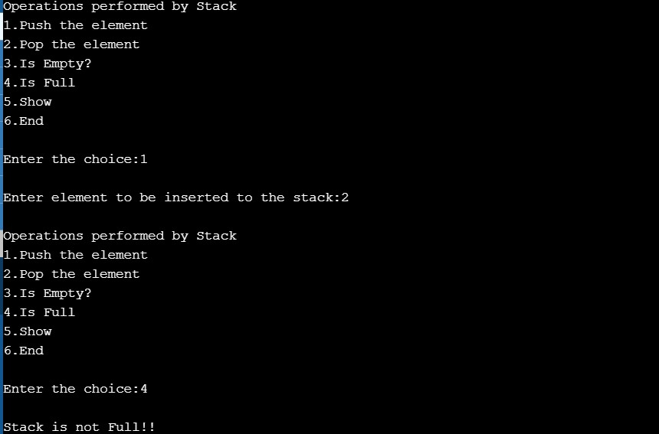

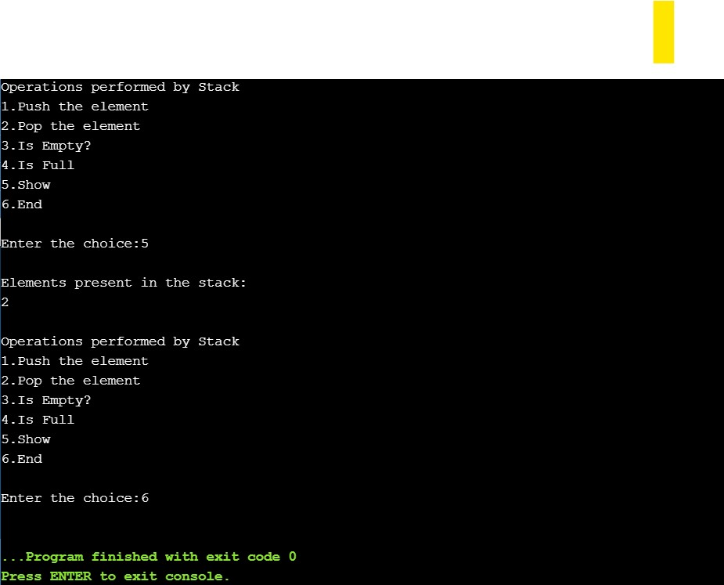

B.3 Observations and learning:
We observe how implemation of stacks are done

B.4 Conclusion:
We have understood the implementation of Stack

B.5 Question of Curiosity

Q.1 Explain stack operations using Linked List.
Soln.
push() : Insert the element into linked list nothing but which is the top node of Stack.
pop() : Return top element from the Stack and move the top pointer to the second node of linked list or Stack.
peek(): Return the top element.
display(): Print all element of Stack

Q.2 Compare stack and queue.
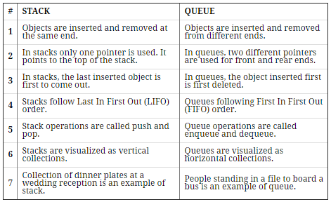

Q.3 Write applications of stack.
Soln.
Stacks can be used for expression evaluation. Stacks can be used to check parenthesis matching in an expression. Stacks can be used for Conversion from one form of expression to another. Stacks can be used for Memory Management. Stack data structures are used in backtracking problems.
PART A
(PART A : TO BE REFERED BY STUDENTS)

Experiment No.02

A.1 Aim:
Implementation of operations on Linked Lists.
A.2 Prerequisite:
C programming
A.3 Outcome:
After successful completion of this experiment students will be,
Implement various operations using linear data structures.
A.4 Theory:
Singly Linked List:
A singly linked list is the simplest type of linked list which is a collection of nodes where each node contains two fields: Data field and Link field.
Data field stores some data and link filed is a pointer to the next node of the same data type. By saying that the node contains a pointer to the next node, we mean that the node stores the address of the next node in sequence.
A singly linked list allows traversal of data only in one way.

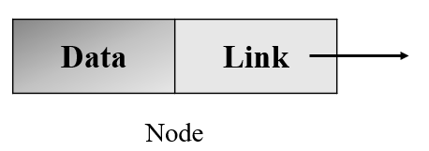
Example of Singly Linked List:

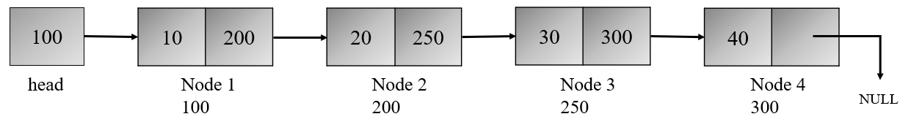

Node Structure:
struct node
{
int data;
struct node *next;
};

Algorithm:
- Create:
Step 1: Initialize head = NULL
Step 2: Repeat step 3 to 7 while ans = ‘Y’
Step 3: Read x
Step 4: Call malloc() to allocate space for new node
Step 5: Set newnode->data = x
Step 6: Set newnode->next = NULL
Step 7: IF head = NULL, then
set head = temp = newnode and go to step 2
else
Set temp->next = newnode
Set temp = newnode
[End of loop]
Step 8: Return head
Step 9: Exit

- Display:
Step 1: Initialize temp = head
Step 2: If head = NULL then
Print List is Empty and go to Step 5
else
Repeat step 3 and 4 while temp != NULL
Step 3: Print temp->data
Step 4: Set temp = temp->next
[End of Loop]
Step 5: Exit

PART B
(PART B : TO BE COMPLETED BY STUDENTS)

(Students must submit the soft copy as per following segments within two hours of the practical. The soft copy must be uploaded on the Blackboard or emailed to the concerned lab in charge faculties at the end of the practical in case the there is no Black board access available)

Roll. No.71 | Name: Omkar Gujja
Class: 2 | Batch: MTRX
Date of Experiment: 20/2/2021 | Date of Submission: 27/2/2021
Grade:

B.1 Software Code written by student:
#include <stdlib.h>
#include <stdio.h>

struct node{
int data;
struct node *link;
};

void print_data(struct node *head){
if (head == NULL){
printf("Linked List is empty.");
}
struct node *ptr;
ptr = head;
printf("\nHere is the LinkedList: ");
while (ptr != NULL){
printf("%d ", ptr->data);
ptr = ptr->link;
}
}

void add_node(struct node *head, int data){
struct node *ptr,*temp;
ptr = head;

temp = (struct node*)malloc(sizeof(struct node));
temp->data = data;
temp->link = NULL;

while (ptr->link != NULL){
ptr = ptr->link;
}

ptr->link = temp;
}

int main()
{
struct node *head = malloc(sizeof(struct node));

int n = 1;
do {
int data;
printf("Enter data : ");
scanf("%d", &data);
add_node(head, data);
printf("Want to add Y(1) or N(0) : ");
scanf("%d", &n);
}while (n != 0);

print_data(head);

return 0;
}

B.2 Input and Output:

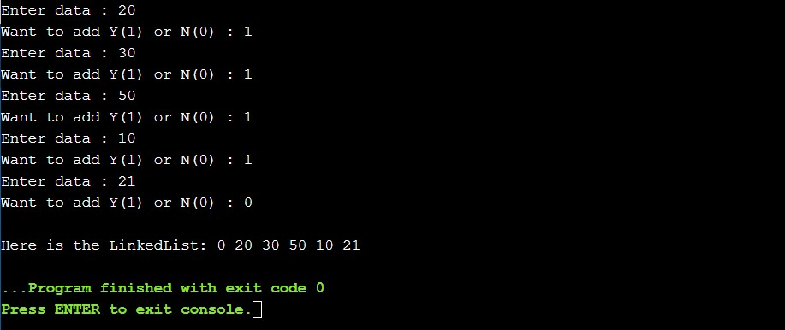

B.3 Observations and learning:
We observe how operations are performed on linked list.

B.4 Conclusion:
We have understood the implementation of operations on a Linked

B.5 Question of Curiosity

Q.1 Explain Inserting a node operation in singly linked list.
Soln.
Step 1 - Create a newNode with given value.
Step 2 - Check whether list is Empty (head == NULL)
Step 3 - If it is Empty then, set newNode → next = NULL and head = newNode. Step 4 - If it is Not Empty then, define a node pointer temp and initialize with head.

Q.2 Explain different types of linked lists.
Soln.
Simple Linked List
Doubly Linked List
Circular Linked List

Q.3 Write applications of Linked Lists.
Soln.
Implementation of stacks and queues Implementation of graphs : Adjacency list representation of graphs is most popular which is uses linked list to store adjacent vertices.

Dynamic memory allocation : We use linked list of free blocks. Maintaining directory of names Performing arithmetic operations on long integers

PART A
(PART A : TO BE REFFERED BY STUDENTS)

Experiment No.03

A.1 Aim:
Implementation of quick sort.
A.2 Prerequisite:
C programming
A.3 Outcome:
After successful completion of this experiment students will be,
Apply divide and conquer strategy to solve problems.
A.4 Theory:
Quick sort:
Quicksort is an algorithm based on divide and conquer approach in which the array is split into subarrays and these sub-arrays are recursively called to sort the elements. It is also called partition-exchange sort.
This algorithm divides the list into three main parts:
- Elements less than the Pivot element
- Pivot element
- Elements greater than the pivot element
Pivot element can be any element from the array, it can be the first element, the last element or any random element.



Example:

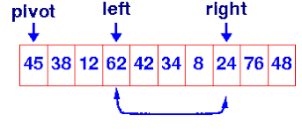
Algorithm:
Step 1: Repeat the steps 2 to 10 while low < high
Step 2: Select Pivot = a[low]
Pivot location p = low
Step 3: i = low and j = high
Step 4: Repeat the steps 5 to 7 while i < j
Step 4: Increment index i till a[i] < pivot
Step 5: Decrement index j till a[j] > pivot
Step 6: Swap a[i] with a[j]
[End of Loop]
Step 7: if i > j then
Swap a[p] with a[j]
Step 8: call quicksort(a, low, j-1)
Step 9: Call quicksort(a, j+1, high)
[End of Loop]
Step 10: Stop

PART B
(PART B : TO BE COMPLETED BY STUDENTS)

(Students must submit the soft copy as per following segments within two hours of the practical. The soft copy must be uploaded on the Blackboard or emailed to the concerned lab in charge faculties at the end of the practical in case the there is no Black board access available)

Roll. No.71 | Name: Omkar Gujja
Class: 2 | Batch: MTRX
Date of Experiment: 27/2/2021 | Date of Submission: 6/3/2021
Grade:

B.1 Software Code written by student:
#include<malloc.h>
#include <stdio.h>

void displayArray(int arr[], int len){
for (int i = 0; i < len; i++){
printf("%d ", arr[i]);
}
printf("\n");
}

void swap(int *a, int *b){
int t = *a;
*a = *b;
*b = t;
}

int partition(int arr[], int l, int h){
int pivot = arr[l];
int start = l;
int end = h;

while (start<end){

do{
start++;
}while(pivot>arr[start]);

do{
end--;
}while(pivot<arr[end]);
if (start<end){
swap(&arr[start], &arr[end]);
}
}
swap(&arr[end], &arr[l]);
return end;
}

void quicksort(int arr[], int l, int h){
if (l<h){
int p = partition(arr, l, h);
quicksort(arr, l, p);
quicksort(arr, p+1, h);
}
}

int *takeInput(){
int size;
printf("Enter the size of the array : ");
scanf("%d",&size);
int *p= malloc(sizeof(size));

printf("Enter the elements in an array : ");
for(int i=0;i<size;i++)
{
scanf("%d", &p[i]);
}
return p;
}

int main()
{
int *arr = takeInput();

int n=sizeof(*arr);

printf("Before sorting : ");
displayArray(arr, n);
quicksort(arr, 0, n);
printf("\nAfter sorting : ");
displayArray(arr, n);
return 0;
}

B.2 Input and Output:
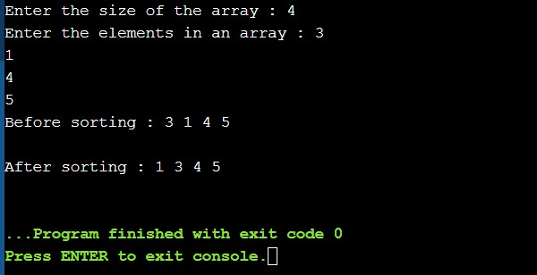

B.3 Observations and learning:
We observe how implemation of quick sort are done.

B.4 Conclusion:
We have understood the implementation of quick sort.

B.5 Question of Curiosity

Q.1 what is the time complexity of quick sort?
Soln.
To sort an array of n distinct elements, quicksort takes O(n log n) time in expectation, averaged over all n! permutations of n elements with equal probability.
Best-case performance
Worst-case space complexity
Worst-case performance
Average performance

Q.2 Explain internal and external sorting.
Soln.
Internal sorting: If the input data is such that it can be adjusted in the main memory at once, it is called internal sorting. External sorting: If the input data is such that it cannot be adjusted in the memory entirely at once, it needs to be stored in a hard disk, floppy disk, or any other storage device. This is called external sorting.

Q.3 Quick Sort follows Divide and Conquer Strategy
a) true b) false
Soln.
- True
Explanation: In quick sort, the array is divided into sub-arrays and then it is sorted (divide-and- conquer strategy).

PART A
(PART A : TO BE REFFERED BY STUDENTS)

Experiment No.04

A.1 Aim:
Implementation of operations on Binary Search Tree.
A.2 Prerequisite:
C programming
A.3 Outcome:
After successful completion of this experiment students will be,
Apply concepts of Trees and Graphs to a given problem.
A.4 Theory:
Binary Search Tree:
A binary search tree is an ordered binary tree. A Binary Search Tree (BST) is a tree in which all the nodes follow following properties –
All the nodes in the left sub-tree have a value less than that of the root (parent) node.
All the nodes in the right sub-tree have a value either equal to or greater than that of the root (parent) node.
These rules are applicable to every subtree in a tree.

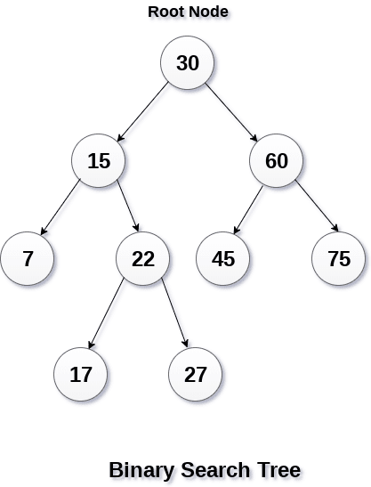

Node Structure:
struct BSTnode
{
int data;
struct BSTnode *left;
struct BSTnode *right;
}

Algorithm:
- Create BST and Insert a node:
Step 1: Call malloc to allocate memory to newnode
Step 2: Set newnode->data and newnode->left = newnode->right = NULL
Step 3: if root = NULL then
root = temp = newnode
return root
else
repeat step 4 while temp != NULL
Step 4: if newnode->data <= temp->data
if temp->left == NULL
temp->left = newnode
return root
temp = temp->left
else
if temp->right == NULL
temp->right = newnode
return root
temp = temp->right
Step 5: Exit

- Display: (Inorder Traversal)
Step 1: IF root != NULL then
Step 2: Inorder(root->left)
Step 3: Print root->data
Step 4: Inorder(root->right)
[End of Loop]
Step 5: Stop

PART B
(PART B : TO BE COMPLETED BY STUDENTS)

(Students must submit the soft copy as per following segments within two hours of the practical. The soft copy must be uploaded on the Blackboard or emailed to the concerned lab in charge faculties at the end of the practical in case the there is no Black board access available)

Roll. No.71 | Name: Omkar Gujja
Class: 2 | Batch: MTRX
Date of Experiment: 6/3/2021 | Date of Submission: 13/3/2021
Grade:

B.1 Software Code written by student:
#include<stdio.h>
#include<stdlib.h>

struct BSTnode {
int data;
struct BSTnode *left;
struct BSTnode *right;
};
struct BSTnode* newNode(int item)
{
struct BSTnode* temp
= (struct BSTnode*)malloc(sizeof(struct BSTnode));
temp->data = item;
temp->left = temp->right = NULL;
return temp;
}

struct BSTnode* insert(struct BSTnode* node, int data)
{
if (node == NULL)
return newNode(data);

if (data < node->data)
node->left = insert(node->left, data);
else if (data > node->data)
node->right = insert(node->right, data);

return node;
}

void inorder(struct BSTnode* root)
{
if (root != NULL) {
inorder(root->left);
printf("%d \n", root->data);
inorder(root->right);
}
}

int main()
{

struct BSTnode* root = NULL;
root = insert(root, 50);
insert(root, 30);
insert(root, 20);
insert(root, 40);
insert(root, 70);
insert(root, 60);
insert(root, 80);

printf("Inorder traversal of BST : \n");
inorder(root);

return 0;
}

B.2 Input and Output:
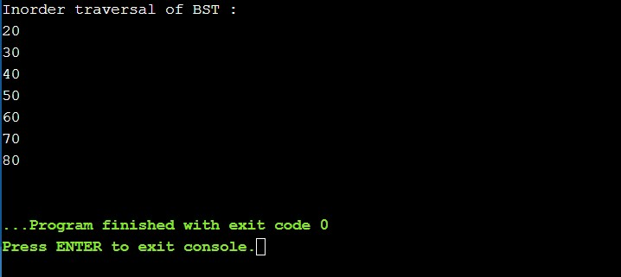

B.3 Observations and learning:
We observe how operations are performed on Binary search tree

B.4 Conclusion:
We have understood the implementation of Binary Tree.

B.5 Question of Curiosity

Q.1 What is binary tree and Binary search tree?
Soln.
IN BINARY TREE there is no ordering in terms of how the nodes are arranged

IN BINARY SEARCH TREE the left subtree has elements less than the nodes element and the right subtree has elements greater than the nodes element

Q.2 Write an algorithm to search an element in a binary search tree
soln.
Step 1: low = 0
Step2: high = n-1
Step 3: while (low <= high) repeat
step 4 through step 6 Step 4: mid = (low + high) / 2
Step 5: Is ( ele = = a[mid]) then Loc = mid goto step 7 Otherwise
Step 6: is ( ele < a[mid])? then high = mid – 1 otherwise low = mid + 1 [end while – step 3]
Step 7: Is ( Loc >= 0 ) ? then Print “search element found at location “, loc Otherwise Print “search element not found”.
Q.3 Construct a Binary search tree by inserting 43, 10, 79, 90, 12, 54, 11, 9, 50

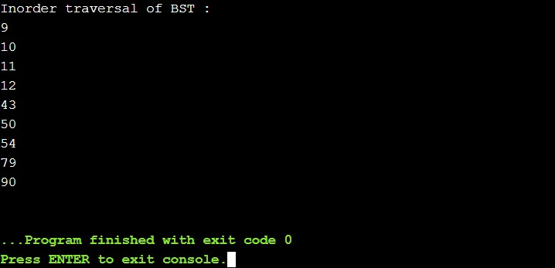

PART A
(PART A : TO BE REFFERED BY STUDENTS)

Experiment No.05

A.1 Aim:
Implementation of Greedy method algorithm - Prim’s algorithm
A.2 Prerequisite:
C programming
A.3 Outcome:
After successful completion of this experiment students will be,
Apply concepts of Trees and Graphs to a given problem.
Apply the concept of Greedy and Dynamic Programming approach to solve problems.

A.4 Theory:
Greedy Algorithm Approach:
A Greedy algorithm is an algorithmic paradigm that builds up a solution piece by piece, always choosing the next piece that offers the most obvious and immediate benefit. So the problems where choosing locally optimal also leads to a global solution are best fit for Greedy.

Prims Algorithm:
Prim's Algorithm is used to find the minimum spanning tree from a graph. Prim’s algorithm is a greedy algorithm that is used to form a minimum spanning tree for a connected weighted undirected graph

Working Principle:
- Prim’s Algorithm works from one vertex and grows the rest of the tree by adding one vertex at a time, by adding the associated edges
- Prim's algorithm starts with the single node and explore all the adjacent nodes with all the connecting edges at every step
- The edges with the minimal weights causing no cycles in the graph got selected

Algorithm:
Step 1: Create a set A that keeps track of vertices already included in MST
Step 2: Assign a key value to all vertices in the graph
Assign key value 0 for the start vertex and ∞ for other vertices
Step 3: While A doesn’t include all vertices in the graph
Pick a vertex v which is not there in A and has minimum key value
Include v to A
Update key value of all adjacent vertices of v

Example:
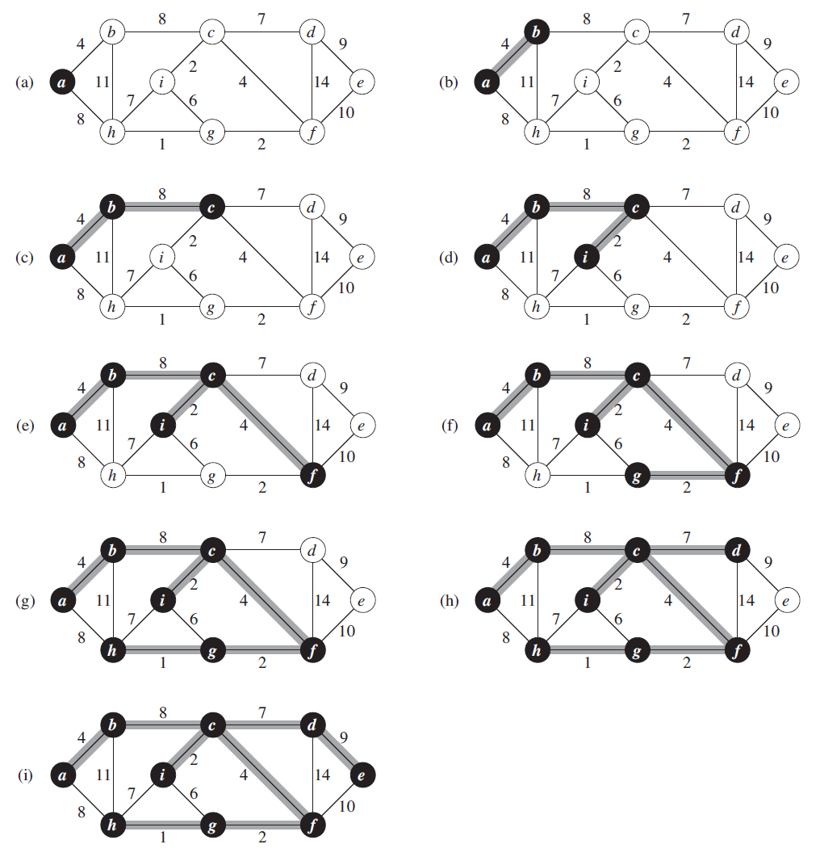

PART B
(PART B : TO BE COMPLETED BY STUDENTS)

(Students must submit the soft copy as per following segments within two hours of the practical. The soft copy must be uploaded on the Blackboard or emailed to the concerned lab in charge faculties at the end of the practical in case the there is no Black board access available)

Roll. No.71 | Name: Omkar Gujja
Class: 2 | Batch: MTRX
Date of Experiment: 13/03/2021 | Date of Submission: 20/03/2021
Grade:

B.1 Software Code written by student:
#include<stdio.h>
#include<stdlib.h>

#define MAX 10
#define TEMP 0
#define PERM 1
#define infinity 9999
#define NIL -1

struct edge
{
int u;
int v;
};

int n;
int adj[MAX][MAX];

int predecessor[MAX];
int status[MAX];
int length[MAX];

void create_graph();
void maketree(int r, struct edge tree[MAX]);
int min_temp();

int main()
{
int wt_tree = 0;
int i, root;
struct edge tree[MAX];

create_graph();

printf("\nEnter root vertex : ");
scanf("%d",&root);

maketree(root, tree);

printf("\nEdges to be included in spanning tree are : \n");

for(i=1; i<=n-1; i++)
{
printf("%d-> ",tree[i].u);
printf("%d\n",tree[i].v);
wt_tree += adj[tree[i].u][tree[i].v];
}
printf("\nWeight of spanning tree is : %d\n", wt_tree);

return 0;

}/*End of main()*/

void maketree(int r, struct edge tree[MAX])
{
int current,i;
int count = 0;/*number of vertices in the tree*/

/*Initialize all vertices*/
for(i=0; i<n; i++)
{
predecessor[i] = NIL;
length[i] = infinity;
status[i] = TEMP;
}

/*Make length of root vertex 0*/
length[r] = 0;

while(1)
{
/*Search for temporary vertex with minimum length
and make it current vertex*/
current = min_temp();

if(current == NIL)
{
if(count == n-1) /*No temporary vertex left*/
return;
else /*Temporary vertices left with length infinity*/
{
printf("\nGraph is not connected, No spanning tree possible\n");
exit(1);
}
}

/*Make the current vertex permanent*/
status[current] = PERM;

/*Insert the edge ( predecessor[current], current) into the tree,
except when the current vertex is root*/
if(current != r)
{
count++;
tree[count].u = predecessor[current];
tree[count].v = current;
}

for(i=0; i<n; i++)
if(adj[current][i] > 0 && status[i] == TEMP)
if(adj[current][i] < length[i])
{
predecessor[i] = current;
length[i] = adj[current][i];
}
}

}/*End of make_tree( )*/

/*Returns the temporary vertex with minimum value of length
Returns NIL if no temporary vertex left or
all temporary vertices left have pathLength infinity*/
int min_temp()
{
int i;
int min = infinity;
int k = -1;

for(i=0; i<n; i++)
{
if(status[i] == TEMP && length[i] < min)
{
min = length[i];
k = i;
}
}

return k;
}/*End of min_temp()*/

void create_graph()
{
int i,max_edges,origin,destin,wt;

printf("\nEnter number of vertices : ");
scanf("%d",&n);
max_edges = n*(n-1)/2;

for(i=1; i<=max_edges; i++)
{
printf("\nEnter edge %d(-1 -1 to quit) : ",i);
scanf("%d %d",&origin,&destin);
if((origin == -1) && (destin == -1))
break;
printf("\nEnter weight for this edge : ");
scanf("%d",&wt);
if( origin >= n || destin >= n || origin < 0 || destin < 0)
{
printf("\nInvalid edge!\n");
i--;
}
else
{
adj[origin][destin] = wt;
adj[destin][origin] = wt;
}
}
}
B.2 Input and Output:
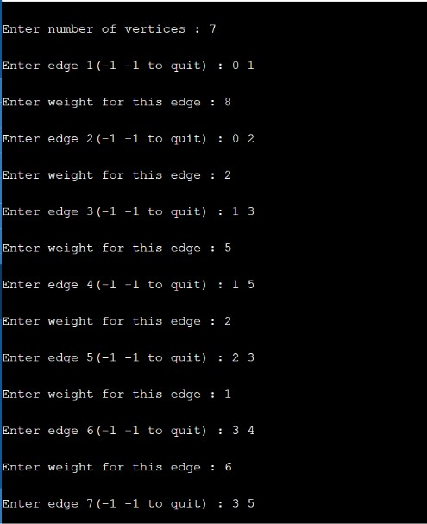

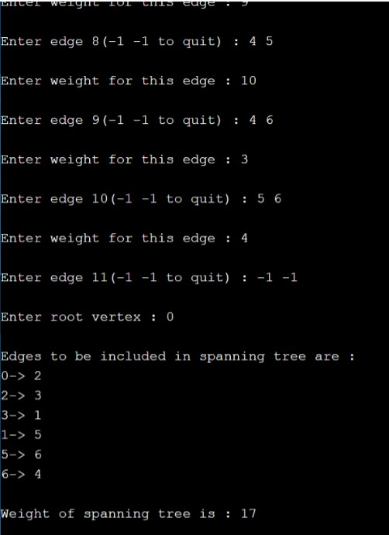

B.3 Observations and learning:
We have observed how Prim's Algorithm works
B.4 Conclusion:
We have understood the Prims’s Algorithm for minimum spanning.

B.5 Question of Curiosity

Q.1 What is minimum spanning tree ?
Soln.
The cost of the spanning tree is the sum of the weights of all the edges in the tree. There can be many spanning trees. Minimum spanning tree is the spanning tree where the cost is minimum among all the spanning trees.

Q.2 What is the difference between Prims and Kruskal’s algorithm
PRIMS ALGORITHM VERSUS KRUSHAL ALGORITHM
PRIMS ALGORITHM | KRUSHAL ALGORITHM
A greedy algorithm that finds a minimum  spanning tree for a weighted undirected  graph. | A minimum spanning tree algorithm which finds an edge of the least possible weight that connects any two trees in the forest
Generates the minimum spanning tree starting from the root vertex | Generates the minimum spanning tree starting from the least weighted edge
Selects the root vertex | Selects the shortest edge
Selects the shortest edge connected to the root vertex | Selects the next shortest edge

PART A
(PART A : TO BE REFFERED BY STUDENTS)

Experiment No.06

A.1 Aim:
Implementation of Dynamic programming approach algorithm - Traveling sales person problem
A.2 Prerequisite:
C programming
A.3 Outcome:
After successful completion of this experiment students will be,
Apply concepts of Trees and Graphs to a given problem.
Apply the concept of Greedy and Dynamic Programming approach to solve problems.

A.4 Theory:
Dynamic Programming Approach:
Dynamic programming approach is similar to divide and conquer in breaking down the problem into smaller and yet smaller possible sub-problems. But unlike, divide and conquer, these sub-problems are not solved independently. Rather, results of these smaller sub-problems are remembered and used for similar or overlapping sub-problems. It refers to simplifying a complicated problem by breaking it down into simpler sub-problems in a recursive manner.
Dynamic programming is used where we have problems, which can be divided into similar sub-problems, so that their results can be re-used. Mostly, these algorithms are used for optimization. Before solving the in-hand sub-problem, dynamic algorithm will try to examine the results of the previously solved sub-problems. The solutions of sub-problems are combined in order to achieve the best solution.

Travelling Sales Person Problem:
The Travelling Salesman Problem (TSP) is the challenge of finding the shortest yet most efficient route for a person to take given a list of specific destinations.
The traveling salesman problems abide by a salesman and a set of cities. The salesman has to visit every one of the cities starting from a certain one (e.g., the hometown) and to return to the same city. The challenge of the problem is that the traveling salesman needs to minimize the total length of the trip.

Example:
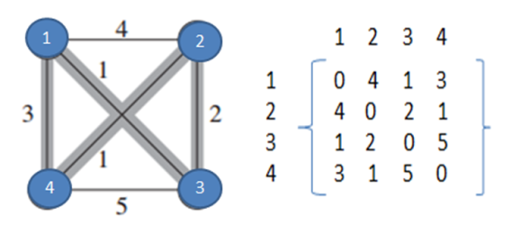

T (i, S) = min [ w(i,j) + T(j, {S-j} ]

T (1, {2,3,4} = min (w(1,2) + T(2, {3,4}) ] = 4 +7 = 11

T ( 1, {2,3,4} ) = minimum of
= { (1,2) + T (2, {3,4} ) 4+6=10
= { (1,3) + T (3, {2,4} ) 1+3=4
= { (1,4) + T (4, {2,3} ) 3+3=6

T (2, {3,4} ) = minimum of
= { (2,3) + T (3, {4} ) 2+5=7
= { (2,4) + T {4, {3} ) 1+5=6

T (3, {2,4} ) = minimum of
= { (3,2) + T (2, {4} ) 2+1=3
= { (3,4) + T {4, {2} ) 5+1=6

T (4, {2,3} ) = minimum of
= { (4,2) + T (2, {3} ) 1+2=3
= { (4,3) + T {3, {2} ) 5+2=7

T ( 3, {4} ) = (3,4) + T (4, {} ) 5+0=5

T ( 4, {3} ) = (4,3) + T (3, {} ) 5+0=5

T ( 2, {4} ) = (2,4) + T (4, {} ) 1+0=1

T ( 4, {2} ) = (4,2) + T (2, {} ) 1+0 = 1

T ( 2, {3} ) = (2,3) + T (3, {} ) 2+0 = 2

T ( 3, {2} ) = (3,2) + T (2, {} ) 2+0=2

T ( 1, {2,3,4} ) = minimum of

= { (1,2) + T (2, {3,4} ) 4+6=10 in this path we have to add +1 because this path ends with 3. From there we have to reach 1 so 3->1 distance 1 will be added total distance is 10+1=11

= { (1,3) + T (3, {2,4} ) 1+3=4 in this path we have to add +3 because this path ends with 3. From there we have to reach 1 so 4->1 distance 3 will be added total distance is 4+3=7

= { (1,4) + T (4, {2,3} ) 3+3=6 in this path we have to add +1 because this path ends with 3. From there we have to reach 1 so 3->1 distance 1 will be added total distance is 6+1=7

- Minimum distance is 7 which includes path 1->3->2->4->1.

PART B
(PART B : TO BE COMPLETED BY STUDENTS)

(Students must submit the soft copy as per following segments within two hours of the practical. The soft copy must be uploaded on the Blackboard or emailed to the concerned lab in charge faculties at the end of the practical in case the there is no Black board access available)

Roll. No.71 | Name: Omkar Gujja
Class: 2 | Batch: MTRX
Date of Experiment: 20/03/2021 | Date of Submission: 27/03/2021
Grade:

B.1 Software Code written by student:
#include<stdio.h>
#include<stdlib.h>
#define MAX 10

struct edge
{
int u;
int v;
};

int n;
int adj[MAX][MAX];
int cost;
int completed[MAX];

void create_graph();
void mincost(int city)
{
int i,ncity;
completed[city]=1;
printf("%d--->",city+1);
ncity=least(city);
if(ncity==999)
{
ncity=0;
printf("%d",ncity+1);
cost+=adj[city][ncity];
return;
}
mincost(ncity);
}
int least(int c)
{
int i,nc=999;
int min=999,kmin;
for(i=0;i < n;i++)
{
if((adj[c][i]!=0)&&(completed[i]==0))
if(adj[c][i]+adj[i][c] < min)
{
min=adj[i][0]+adj[c][i];
kmin=adj[c][i];
nc=i;
}
}
if(min!=999)
cost+=kmin;
return nc;
}
int main()
{
struct edge tree[MAX];
create_graph();
printf("\n\nThe Path is:\n");
mincost(0); //passing 0 because starting vertex
printf("\n\nMinimum cost is %d\n ",cost);
return 0;
}/*End of main()*/
void create_graph()
{
int i,origin,destin,wt;
printf("\nEnter number of vertices : ");
scanf("%d",&n);
for(i=1; i<=n*n; i++)
{
printf("\nEnter edge %d(-1 -1 to quit) : ",i);
scanf("%d %d",&origin,&destin);
if((origin == -1) && (destin == -1))
break;
printf("\nEnter weight for this edge : ");
scanf("%d",&wt);
if( origin >= n || destin >= n || origin < 0 || destin < 0)
{
printf("\nInvalid edge!\n");
i--;
}
else
{
adj[origin][destin] = wt;
}
}
}

B.2 Input and Output:
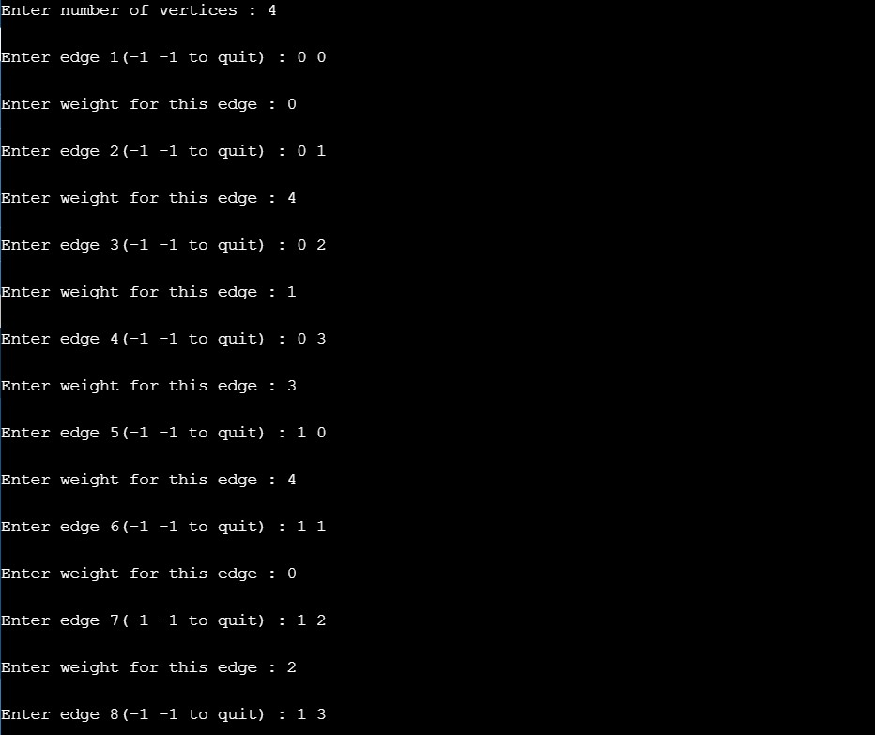

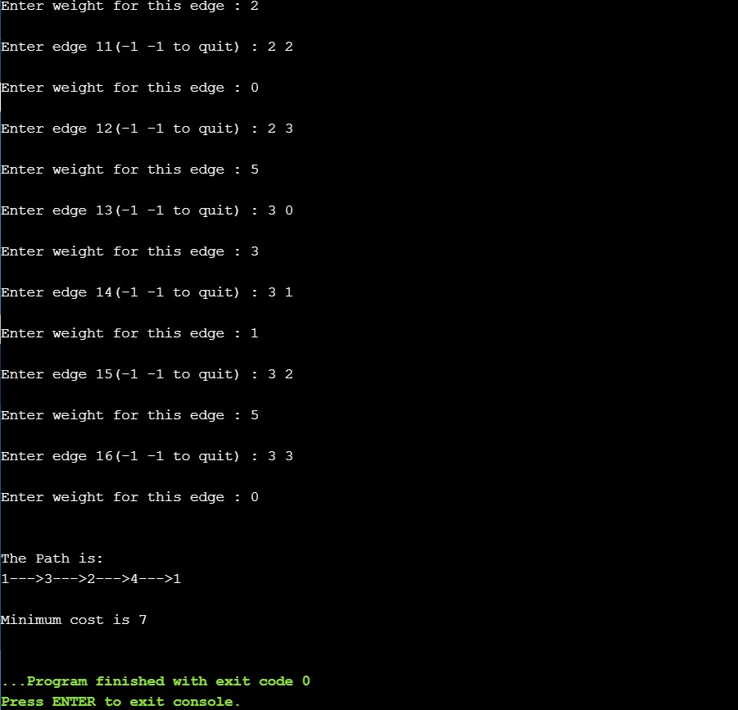

B.3 Observations and learning:
We have learned how Dynamic Programming works.

B.4 Conclusion:
We have understood the program of Travelling Sales Problem.

B.5 Question of Curiosity

Q.1 Travelling salesman problem is an example of
a. Dynamic Algorithm
b. Greedy Algorithm
c. Recursive Approach
d. Divide & Conquer
Soln.
Dynamic Algorithm

